Direct Deposit Authorization Form

Please print and complete ALL the information below.
Name: ____________________________________________________________
Address: ____________________________________________________________
City, State, Zip: ____________________________________________________________
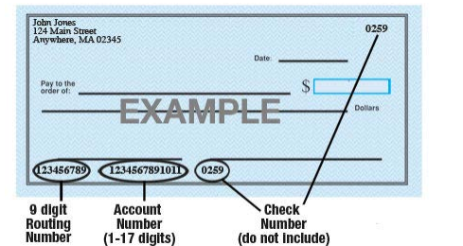
Name of Bank: ____________________________________________________________
Account #: ____________________________________________________________ 9-Digit
Routing #: ____________________________________________________________
Amount: ☐ $ ____________ ☐ ___________% or ☐ Entire Paycheck
Type of Account: ☐ Checking ☐ Savings (Check One)
Attach a voided check for each bank account to which funds should be deposited (if necessary)
I (we) hereby authorize AccuServe Payroll LLC, to initiate electronic credit entries to the accounts identified in the Banking Information sections above, andtodebit my (our) account if necessary to correct erroneous credits. I (we) acknowledge that the origination of ACH transactions to my (our) account must comply This authorization will remain in effect until I modify or cancel it in writing.
Employee’s Signature: _________________________________________ Date: ________________

